Answers 2018
Question 1
- Answers

- The student will need to expand the following: Concept design –taking requirements and investigating different design options that would meet the requirement; system design – design at the black box level to understand system behaviour and performance; detailed design breaking open black boxes to understand design including interfaces, costs and performance; designing the fabrication process – how is to be built; building/constructing/manufacturing; testing and commissioning- the transition to operations.
- Product development is about designing the product or output from the project, and the delivery mechanism is about deigning the project to deliver – both must be integrated into a unique undertaking.
- The all relate to risk management – some processes are focused on risk identification; some on-risk evaluation and some on-risk management.
- Student should develop or describe something like the following:

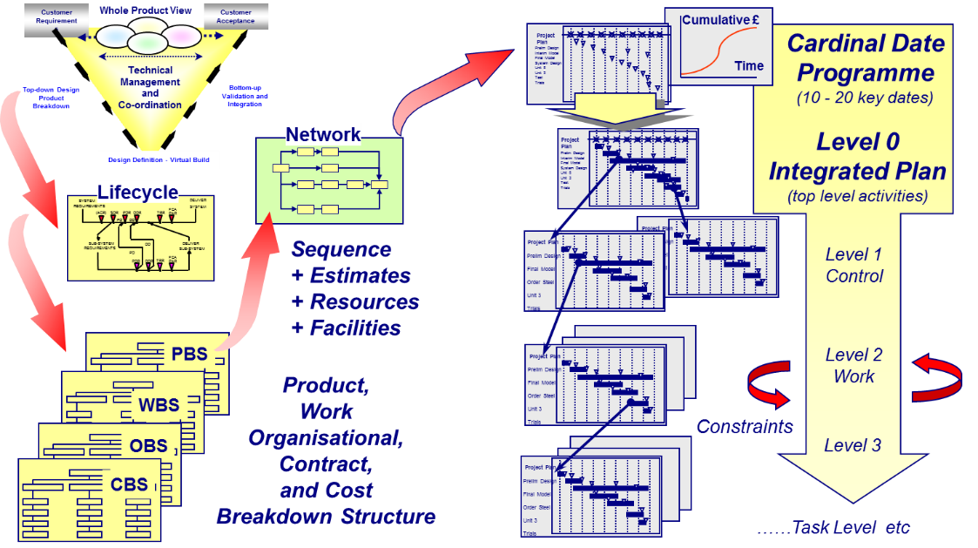

- Either or both of the following diagrams or word descriptions

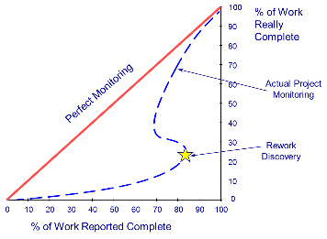
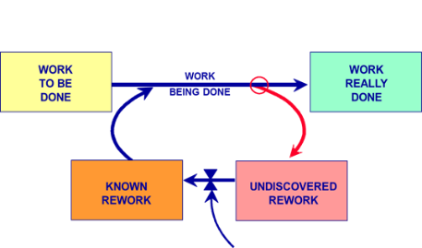

- An example here would be the Olympic Games or the launch of an Apple IPhone.
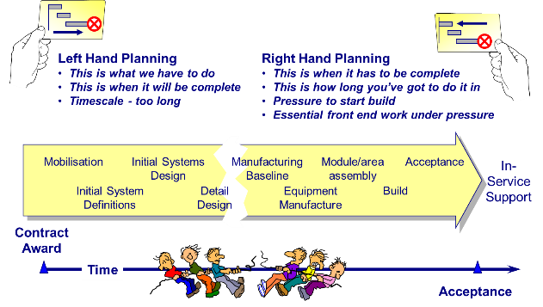
- An integrated project team is made up of the client’s project team and the supply team of consultants, constructors, and specialist suppliers. It brings together the design and construction activities, with maintenance considered as well, whether or not the integrated project team will be responsible for the ongoing maintenance of the facility; it involves valued input from all parties in the supply team. Working together improves project timing, reduces rework and improves understanding.

Question 2
- High reliability organisations are those that manage to avoid accidents in environments/industries where accidents are expected or likely, due to inherent risk. Examples of industries where HROs could be expected include air traffic control, nuclear power stations, mega structure construction projects and crisis response teams. An ability to reinvent themselves and respond to situations that evolve quickly are also hallmarks of successful HROs, as well as learning from accidents in a way that improves future performance and processes and prevents the same type of accident from happening again. An example being an Air Traffic Control service or A Nuclear power Station.
- Preoccupation with Failure
Systems in modern organizations are complicated, and they experience failures. HROs focus like a laser on failure; they give “continuous attention to anomalies that could be symptoms of larger problems.” The basic insight here is that big problems don’t emerge fully formed in an instant. They are almost always preceded by smaller problems or anomalies, or evidence that would point to the big problem if it were given proper attention. What HROs Do NOT is assume that if a control in place succeeds in containing a failure, everything is right. They look deeper into an incident to find underlying causes. They also do not lump a failure with common elements to another into a class that all are alike. Evidence is gathered and evaluated.

Reluctance to Simplify
Complexity means that organizations have numerous potential sources of failure, and HROs do not apply generalized terms to describe them. It is a common and convenient response to a problem to name a general kind of cause and consider it a solution, e.g., ‘the bank has a state-of-the-art alarm system’ so the failure of the alarm can be fixed by replacing it. What if the alarm’s failure is caused by something deeper, what specifically was the cause? In HROs, the occurrence of a failure is taken as an opportunity to dig deeply into the details of the system involved to find a real cause-you differentiate the details within those broad, convenient generalizations.

Sensitivity to Operations
Operations happen in real time; they include both discrete components and the system they compose. As such, operations generate outcomes that we can observe. The HRO continuously evaluates outcomes to determine if they are in fact serving the objectives of the organization. They do not assume that the continuous outcomes will be the same as planned, assumed, or hoped for.
Operations are what an organization does. In this sense, HROs treat them as hands-on experiences from which lessons about the organization can be taken to further improve function in real time.

Commitment to Resiliency
“The signature of the high reliability organization is not that it is error-free, but that errors don’t disable it.” HROs are essentially adaptable, learning organizations. They can experience a failure but continue operating under degraded conditions while marshalling resources to restore capacity.
To operate like this, HROs can recognize emerging anomalies despite prior beliefs, experiences, or plans. In large part, this requires both open-minded observation and a willingness to react appropriately even under unanticipated conditions.

Deference to Expertise
The fact that an HRO must be open-minded rather than judgmental leads to the idea that the culture of the HRO defers to expertise. The key point, however, is that the “expert” involved is the person with hands-on knowledge of the operation at the point of a failure, not the “expertise” conferred by hierarchical authority.
In the HRO, the expert has access to upward reporting, and there is no intimidation from authority to impede the communication. The openness required for the HRO to succeed depends on accurate information from every source.

- The short discussion should relate to shareholders seeing profits as a key to wealth creation and the costs associated with being an HRO. There is always a tendency to cut the cost of operations in order to increase profits. Safety is often the target for cuts and hence this will increase the risk of accidents and/or heavy penalties.

3.
a.
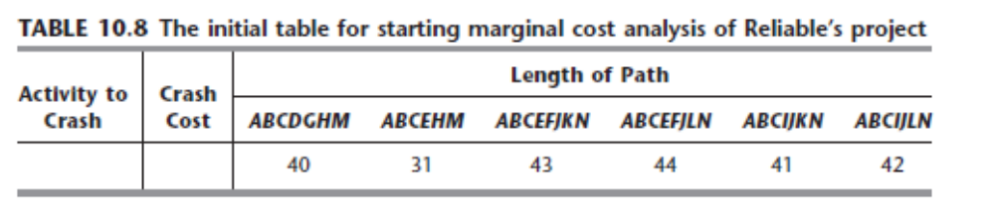
b.
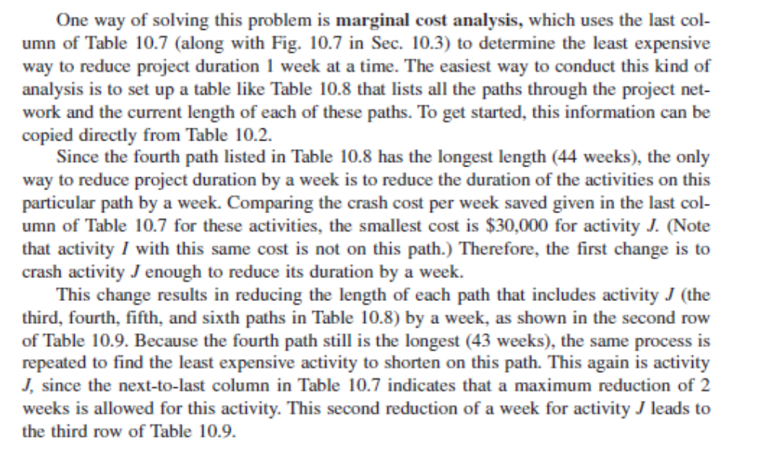
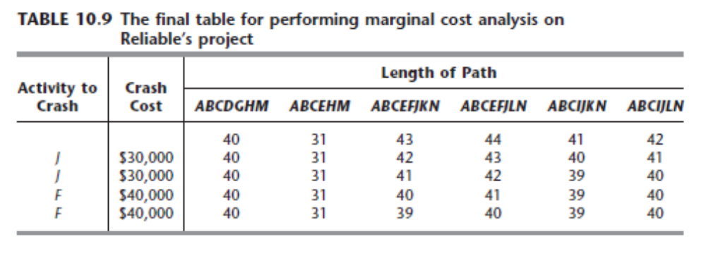
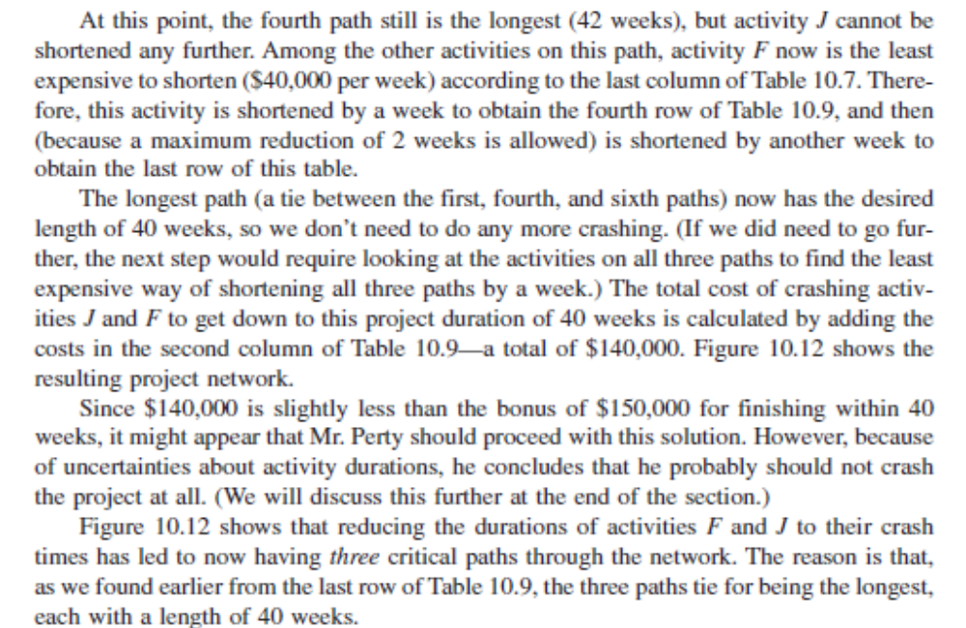

4.
(a)
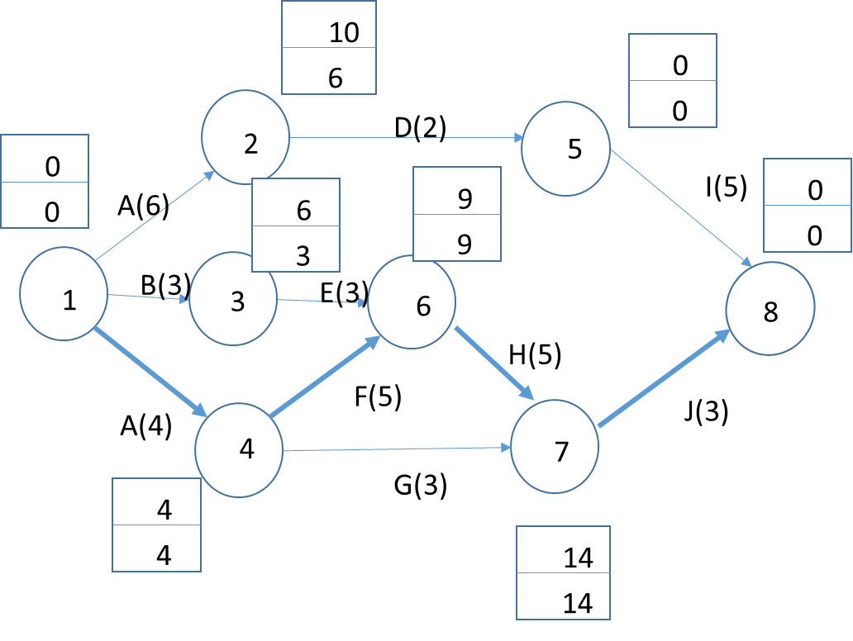

(b)
Activity | Build logic | Pessimistic Time | Medium Time | Optimistic Time | Mean | Variance
A | -- | 5 | 6 | 7 | 6 | 0.11
B | - | 1 | 3 | 5 | 3 | 0.44
C | - | 1 | 4 | 7 | 4 | 1.0
D | A | 1 | 2 | 3 | 2 | 0.11
E | B | 1 | 2 | 9 | 3 | 1.78
F | C | 1 | 5 | 9 | 5 | 1.78
G | C | 2 | 2 | 8 | 3 | 1.0
H | E, F | 4 | 4 | 10 | 5 | 1.0
I | D | 2 | 4 | 8 | 5 | 1.0
J | H,G | 2 | 2 | 8 | 3 | 1.0

(c)
On network above

(d)
C, F, H, J = 17 weeks
(e)
$$P\left(x≤22\right)=P\left(\frac{x-μ}{σ}\right)=P\left(z≤2.28\right)=98.87\% probability of completion in 22 wweks$$
(f)
$$P\left(x≤20\right)=P\left(\frac{x-μ}{σ}\right)=P\left(z≤1.37\right)=41\% probability of completion in 20 wweks$$
(g)
The summation of variances from activities on the critical path is not permitted. Monte Carlo simulation with combine variances statistically by iterating values some 1000+ times.

